**Step 1:** Creating an IAM group

* In the IAM panel, click on *Groups*, and you will land on the *Create New Group* page

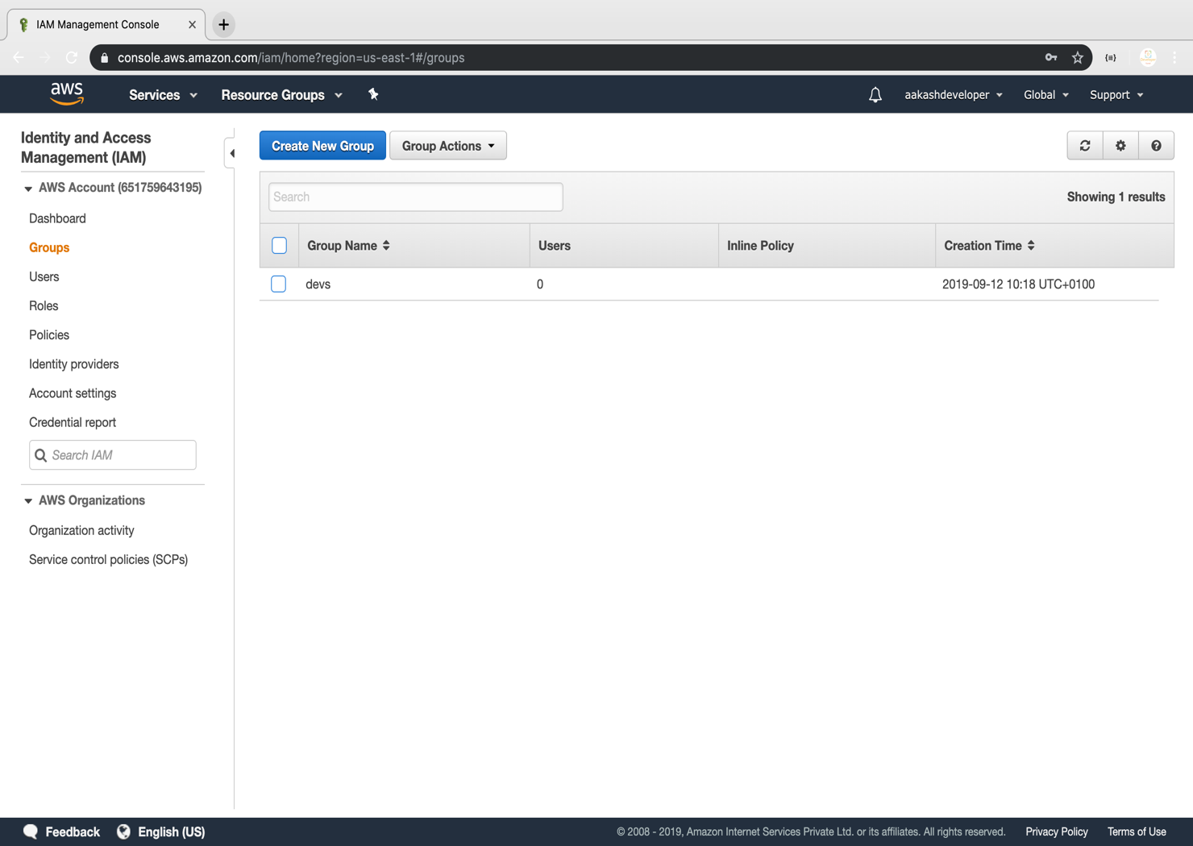

* Enter the group name

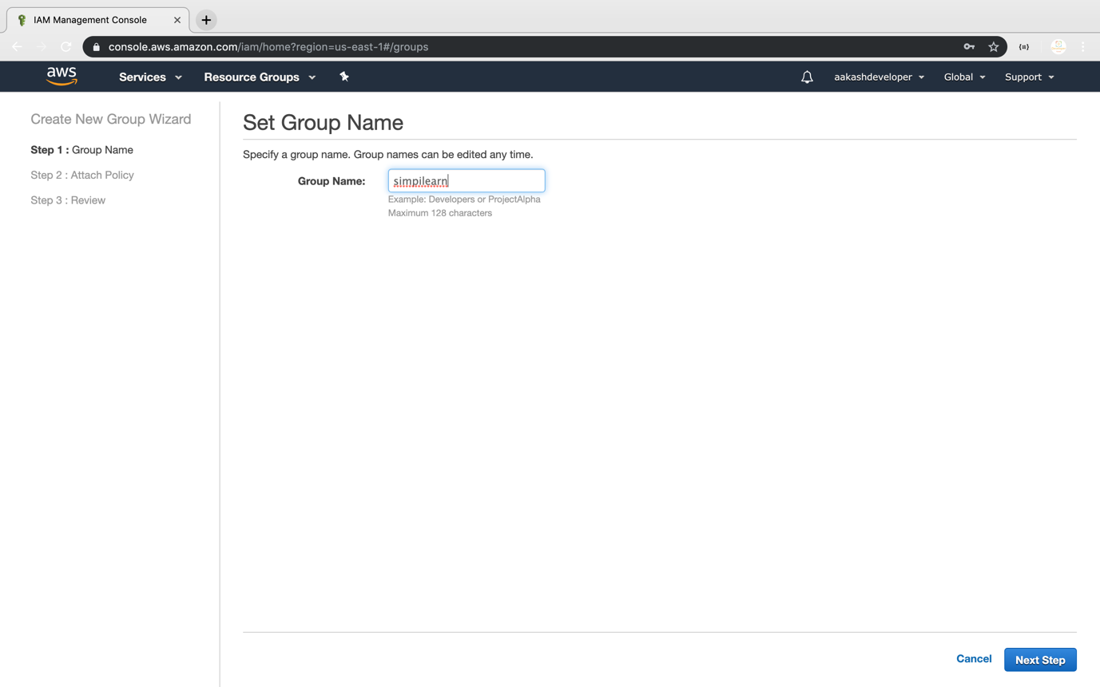

**Step 2:** Assigning the required policy to the group

* Assign the policy provided by AWS

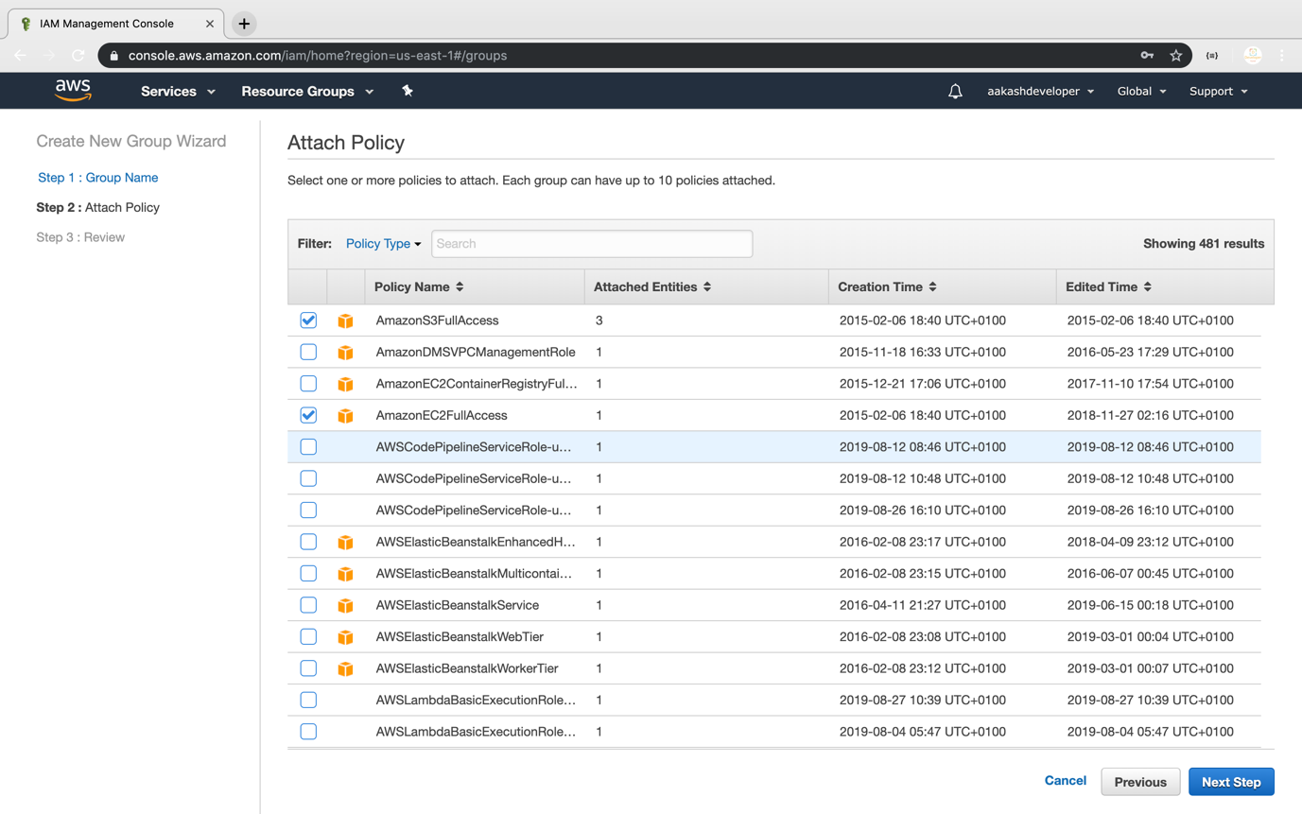

* Once the group is created, you can see the new group in the console

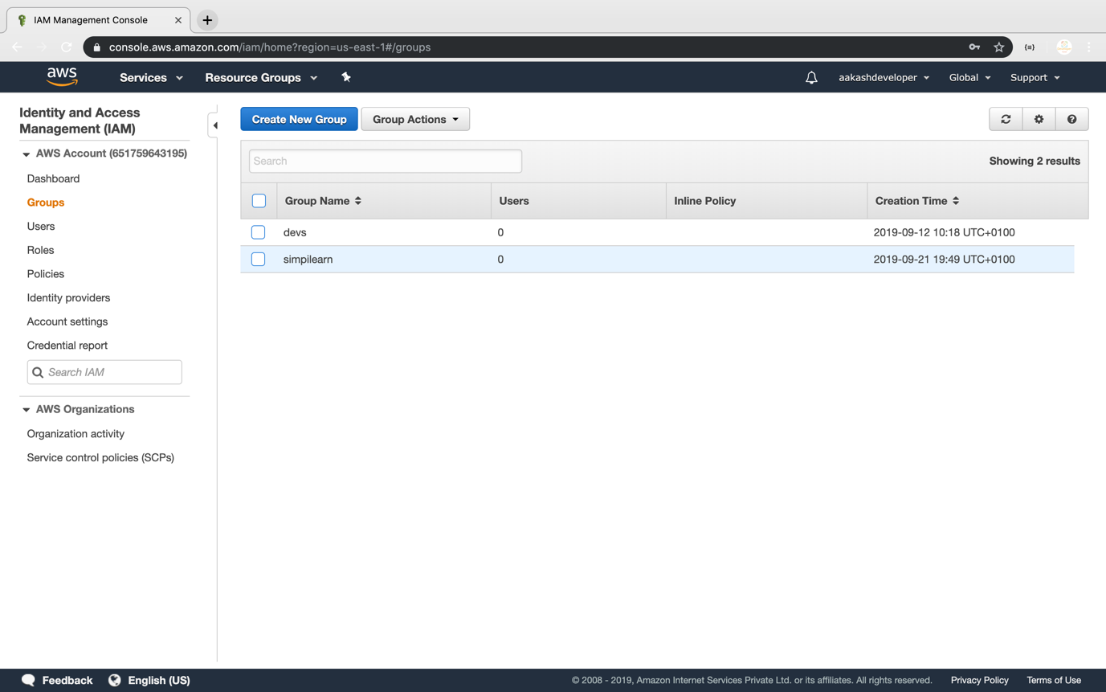

* You can add a user or a policy to the group any time

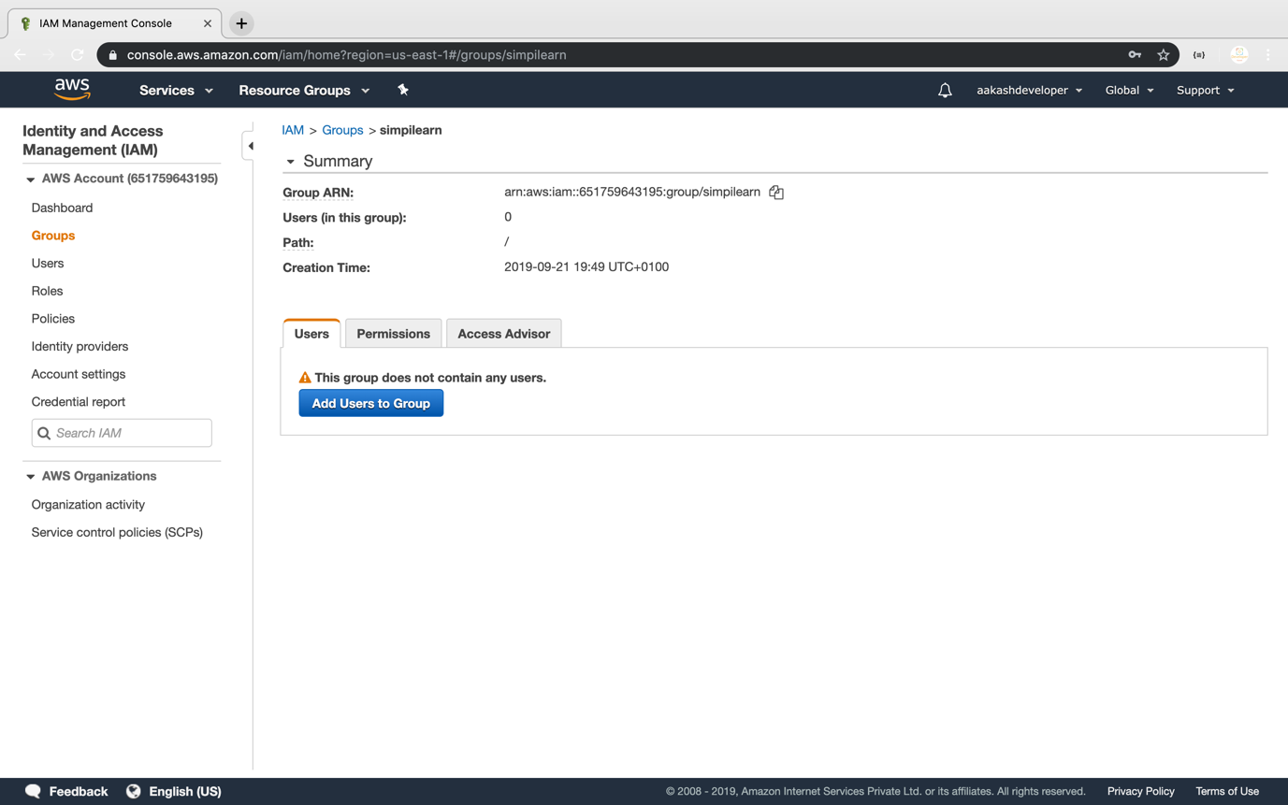

* You can see the user list by clicking on *Add User*

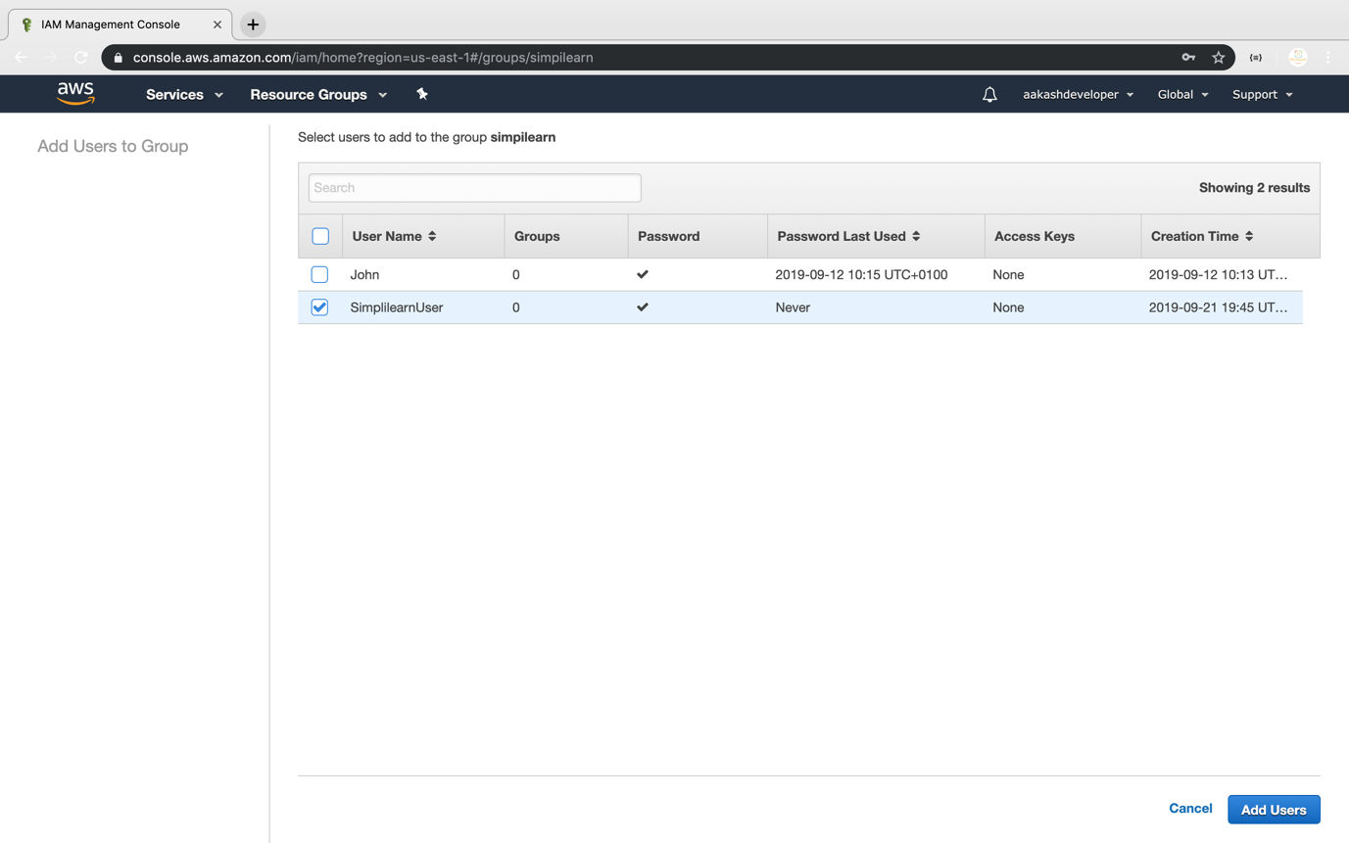

* You can also find all the policies added to the group

